

SEN Information Report 2026/2027

Welcome to our SEND Information Report. On these pages you should be able to find the answers to frequently asked questions about what the school offers for children with a Special Educational Need.

Our vision at St Thomas More Catholic Primary School is we believe all children are valued individuals with unique interests and strengths. We believe ‘all children have equal rights of access to a broad and balanced curriculum and have the right to be included in all aspects of school life’ (DfE Special Educational Needs Code of Practice 2015).

At St Thomas More we celebrate and value the uniqueness of the individual and aim to find the gift in each child. We believe childhood lasts a lifetime and that each child is ‘created in the image and likeness of God.’ (Genesis 1:27)

Some children, at some time in their life may have a Special Educational Need or Disability (SEND) whether it be academic, social, emotional or physical and as a school. We believe in providing effective learning opportunities and outcomes for all. We take a truly holistic approach to supporting all our pupils whilst providing a high-quality provision that meets their individual needs. We are passionate in our drive to encourage and support all pupils to achieve their full potential in all areas of school life within a safe, nurturing and enriching learning environment. We actively encourage parents to be involved in the education of their child and see effective home-school partnerships as key to a pupil’s success.

Our school’s core values underpin the inclusive environment at St Thomas More. Some children may need additional support during their time with us, while a few children will require more precise individualised support. This document aims to provide details of our Quality SEND Offer and provides an outline of what services and support are available to parents and carers to help their child succeed. It has been reviewed in conjunction with parents and governors. It contains links to policies and documents (found on our website) which give further details as to our approach to supporting children with SEND.

What are Special Educational Needs and Disability (SEND)?.......................................................................................................................................3
How does the school know whether my child needs extra help?.................................................................................................................................4
What should I do if I think my child may have a special educational need or disability?............................................................................................ ..6
How will the school support my child?......................................................................................................................................................................7
How will I know how my child is doing?.............................................................................................................................................................. ....9
How will the school’s approach to teaching and learning be matched to my child’s needs?...................................................................................... ..10 What support will there be for my child’s overall wellbeing?.....................................................................................................................................11
What training do the staff supporting children and young people with SEND receive?................................................................................................14
What specialist services and expertise are available at or accessed by the school?.....................................................................................................15
How will you help me to support my child’s learning?..............................................................................................................................................16
How does the school enable constructive partnership working with families?.............................................................................................................17
How will my child be included in activities outside the classroom including school trips?.............................................................................................18
How accessible is St Thomas More?.......................................................................................................................................................................19
How will my child be supported when joining St Thomas More Catholic Primary School or transferring to a new school?..............................................20
How are the school’s resources allocated and matched to children’s special educational needs and disabilities?...........................................................21
How are decisions made about the range of support my child will receive?...............................................................................................................22
Who can I contact for further information?.............................................................................................................................................................23
Where can I find out about the local authority’s Local Offer of services and provision for children with SEND?.............................................................24

What are Special Educational  Needs and Disability (SEND)?  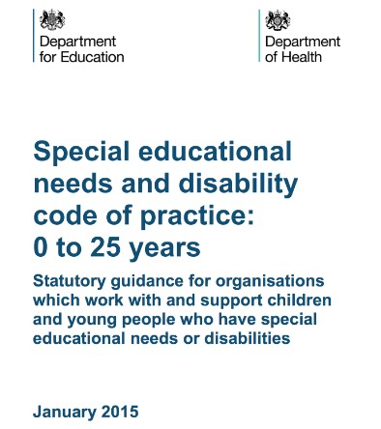 | Special Educational Needs and Disability is the term that is used to describe pupils who have needs over and above those that can be met by high-quality personalised teaching (Quality First Teaching). These needs may be within areas of:  - Communication and Interaction (speech and language needs and or social communication needs).  - Cognition and learning (specific learning difficulties).  - Social, emotional and mental health needs (SEMH).  - Physical or Sensory difficulties.  The support a pupil may need could be for a short period or throughout their education. All staff at St Thomas More are proactive in identifying additional needs of pupils early on and then initiating an individual teaching plan, taking into account their individual needs and experiences. This is referred to as Early Intervention. Meeting the needs of pupils with SEND is the responsibility of all teachers and support staff. These needs are usually met through a differentiated curriculum. The SENDCo, will support staff to meet these needs.  We operate a tiered approach to supporting all pupils including those with additional emotional or learning needs. This tiered approach is detailed under the “How will I know how the School Supports my child?” section, however it always begins with Quality First Teaching.  Overview of St Thomas More Catholic Primary School:  - The percentage of pupils with SEND Support (no EHCP) is register is 9% compared with the National Average of 14.8%.  - The percentage of pupils with an EHCP is 3 % compared with the National Average of 6%  - The largest area of need is Communication and Interaction, followed by SEMH. This is in line with the National picture of need.  - 75% of children with an EHCP are boys, this is broadly in line with national data (June 2026).

How does the school know whether my child needs extra help?  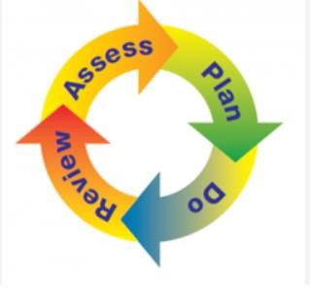 | At different times in their school life, a pupil may have a special educational need or disability (SEND) which could impact their physical, social or intellectual abilities. The Code of Practice 2015 defines SEND as follows: “A child or young person may have SEND if they have a learning difficulty or disability which calls for special educational provision to be made for him or her.  A child of compulsory school age or a young person has a learning difficulty if he or she:  - has a significantly greater difficulty in learning than the majority of others of the same age  - has a disability which prevents or hinders him or her from making use of the facilities of a kind generally provided for others of the same age in mainstream schools or mainstream post-16 institutions.  Where a child’s progress is significantly slower than that of their peers, or fails to match their previous rate of progress, despite high-quality teaching targeted at specific areas of difficulty, it may be that they have SEND.  If the school has identified this, a meeting will be arranged with the child’s parents where information will be gathered, in order to seek their views and discuss any aspects of need at home. We will also meet with the child to discuss their views on how they feel they are doing and what support they feel they may need in school.  We follow the ‘Assess - Plan - Do - Review’ model of intervention and support and include the pupil and parents in this process. We take many opportunities to review progress in school such as through observations/reports from outside agencies or health care professionals, ongoing teacher assessment from formative and summative assessment as well as information shared at termly parent meetings. We also regularly assess and analyse the data in termly Pupil Progress Meetings, where the Senior Leadership Team and teachers meet termly to identify pupils that require interventions or additional support.

We take the following graduated approach to identifying and supporting pupil’s needs:

- Teacher identifies a concern, adjustments made accordingly and notes recorded on plans. Informal conversations with parents to establish concerns and gain parent views. Pupil voice noted to establish any concerns pupil may have.

- If Step 1 proves ineffective, SENDCo advice sought. APDR put in place. Formal meeting with parents to establish targets and share strategies.
- Child placed on Inclusion Register (with parental consent)
Referrals to external agencies made if progress not seen from targeted intervention. After all Local Authority advice has been sought and followed, if progress still not seen, communication with parents around further planned actions eg Education Health Care Plan assessment.

What should I do if I think my child may have a special educational need or disability?  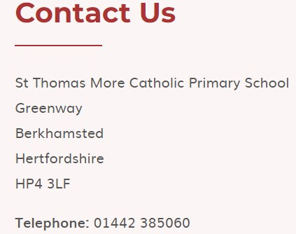 | All staff work closely together to support you and your child throughout your child’s time at St Thomas More. Parents of children with SEND or parents who have concerns should first contact their child’s class teacher to discuss any concerns or issues they have with SEND provision.  The SENDCo (Caroline Manning) will be notified of any concerns by the teacher or you as a parent can raise your concerns with the class teacher (in the first instance) or with the SENDCo.  Contact can be made either by phoning school or by making an appointment through the school reception or emailing the school on admin@stmore.herts.sch.uk

How will the school support my child?   | The Executive Head Teacher has the overall responsibility for the provision of SEND. Caroline Manning is the designated SENDCo who is responsible for the leadership and day-to-day management of SEND provision. There is also a designated SEND governor (Laura Coward).  St Thomas More has an inclusive ethos and is committed to ensuring all pupils receive a high quality education and realise their potential regardless of any barriers they may face. The majority of pupils with SEND are educated in the classroom, however, they will receive intervention and support (from teachers and teaching assistants) on a personalised and individual level, matched appropriately to their needs.  Children with a more significant need may receive support from outside professionals, this is always in consultation with parents.  Class teachers will:  - check on the progress of every pupil and identify, plan and deliver any additional support pupils may need in liaison with the SENDCo  - adapt teaching and learning as identified on the class provision maps  - complete SENDCo support plans for relevant children with support from SENDCo  We offer a graduated approach to supporting all pupils. Firstly, it involves teachers, SENDCo and parents and then appropriate professionals, who can offer support and guidance as needed.  Below details the tiered approach we take:  • Tier 1 – Universal: Most children will make progress through minor adjustments to quality first teaching. In this tier, the pupil may receive individual support in the classroom, one to one support, small focus group work and/or intervention groups. They may be given work that is differentiated or be given scaffolds in order to complete a task.
• Tier 2 – Targeted: This tier involves making reasonable adjustments within the classroom, with suggestions from the SENDCo. For these pupils, who we believe may require further professional involvement, we set up SEND Support Plans to monitor the impact of interventions. These are developed and reviewed termly by teachers, with input as mentioned above. The progress and attainment of pupils are regularly monitored and reviewed. Parents are consulted with and provide input to any approach that may be suggested by the school. We also have Class Provision Maps, which give an overview of the class profile, focus pupils and planned interventions.

Tier 3- Specialist: The final tier involves any pupil who may require more intensive support or an individualised curriculum. The individualised curriculum will be provided by one to ones and TAs under guidance from the SENDCo and external agencies.

Children who have an Education Health Care Plan (EHCP) receive the necessary provision within the aforementioned tiered approach. Professional support and in-class support are personalised according to their needs. The EHCP is reviewed annually with parent and professional input. In the rare cases where High Needs Funding is granted, the school will adjust staffing and support with the individual pupil and other children’s needs in mind.

The SENDCo will also apply for any Localised Funding for children who may not have EHCP’s but may require additional resources. Parents’ Evenings are held in Autumn and Spring Term, where parents are informed of any support received and given feedback about the progress their child has made.

Termly meetings are held with parents and SENDCo for children who are having Tier 2 or Tier 3 support.

How will I know how my child is doing?   | St Thomas More has high aspirations for all of our pupils and monitors progress carefully. Your child’s progress will be monitored by his/her class teacher and this will be reviewed formally at pupil progress meetings. Parents and carers of all children are invited to parent/teacher consultation meetings twice a year.  A wide range of assessments are undertaken and data is collated and reviewed termly or at earlier points as appropriate. This data allows us to ensure that pupils are making progress and that any gaps are addressed quickly. Feedback is given to parents at parent consultation meetings. And ‘End of Year’ written report is provided for parents at the end of the Summer term.  If a child has a SEND support plan, targets will be reviewed with the parents and children termly with the SENDCo and next steps planned together.  In addition to the reports and consultation meetings, we operate an “open door” policy whereby parents are welcome to meet with members of staff to review any concerns they may have with the progress and attainment of their child.  The end of the school day is an ideal time to meet your child’s class teacher and these appointments can be arranged through the school office. We also have the ‘Marvellous Me’ app which allows parents to see work and activities their child has engaged with during the week.  More formal and longer meetings can be arranged with members of staff via the school office.

How will the school’s approach to teaching and learning be matched to my child’s needs?  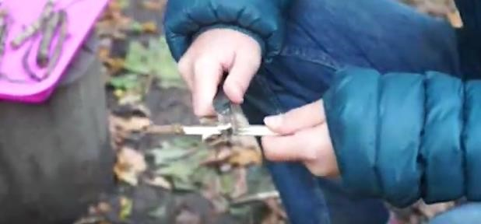 | At St Thomas More, we recognise our responsibility to provide a broad and balanced curriculum for all children. High quality teaching is our main focus and we ensure that learning opportunities are matched to pupil’s abilities and interests.  Teachers are accountable for the progress of all pupils in their class even when they access support from elsewhere.  Teachers set high expectations for every pupil irrespective of their prior attainment, they set suitable learning challenges and enable children to overcome potential barriers to their learning.  Children will be fully supported to access the curriculum according to their needs, which may be through one to one support (with a teacher or teaching assistant), access to an intervention programme or by working in smaller groups.  Interventions may be run by a teacher or a teaching assistant. Staff ensure any additional support is tailored to meet the child’s needs and will target the area of difficulty.  Teachers focus on adapting their planning to ensure that work is appropriate for the individual needs of every child. They work hard to ensure that all children are able to access the curriculum successfully while maintaining a high level of challenge to ensure children make excellent progress in their learning.  Scaffolds are often provided to support pupils in achieving learning questions to their maximum ability. Teachers follow the guidelines for an inclusive classroom to ensure their classrooms are welcoming, support all learners and enable pupils to independently access resources. When children are placed on the SEND register, Support Plans are written to identify strengths of the pupil and specific strategies to support them. Parents are consulted and are invited to provide
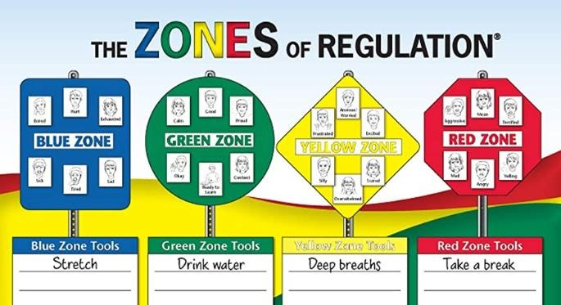 | input into ‘Parent Voice’ and children are also consulted and provide input into, ‘Pupil Voice.’ These plans are reviewed termly with teachers, SENDCo and parents.  All staff adopt a positive approach to behaviour management and develop pupils’ self-regulation skills through use of ‘Hertfordshire’s Therapeutic Thinking Approach to behaviour’ and ‘Zones of Regulation’ in order to create positive learning behaviours.  Our curriculum is designed to ensure that it:  - Has the needs of the pupils at the heart of everything we do  - Has a strong focus on emotional wellbeing  - Is based on a strong foundation of active learning  - Is full of enriching and enjoyable learning experiences  - Provides opportunities for our children, staff and parents to all learn together  - Prepares our children to become positive role models in and effective contributors to society  - Gives our pupils the chance to become the very best version of themselves  - Gives pupils the opportunity to state what they want to learn and do Positively impacts academic outcomes

What support will there be for my child’s overall wellbeing?   | ‘Pupils are happy and well cared for by the school staff. Relationships between adults and pupils are warm and friendly. Bullying is very rare. Pupils show tolerance and respect for their peers.’ (Ofsted Report 2022)  The children’s health and emotional well-being are of paramount importance and the school has clear policies around things such as medical needs and bullying. We also follow a structured PSHE programme and all classrooms use the Zones of Regulation as part of the daily routine as a way of supporting children recognise their emotions and find ways to enhance their wellbeing.  Our Mental Health Lead is Caroline Manning and Caroline McLoone is a trained Mental Health First Aider.  As a school we are able to offer Drawing and Talking therapy to support relevant children’s wellbeing. We also benefit from having a trained Emotional Literacy Support Assistant (ELSA) who is able to work with children requiring support to develop emotional literacy skills.  Some children may require further provision and so we have links services that can provide this specialist support such as DESC, Specialist advisory teachers, school nursing team and CAMHS.  Pupils with SEND are inclusively taught within an age-appropriate class with their peers. We have the following support available for children during their time at school:  - Meetings with a trusted adult (class teacher or teaching assistant at school) which may involve supporting children with emotional regulation.  - Support from trusted adults, mental health lead/support worker  - Use of resources such as Zones of Regulation  - Class strategies such as regular sensory/mindfulness breaks  - Teaching and resources are differentiated within the classroom to ensure children are able to achieve objectives.
- If additional support is required, we provide a range of interventions, including individual or small group work. With the permission of the parents or carers, the SENDCo will be able to access extra support from external agencies. Adults working with a pupil communicate regularly to ensure a consistent approach to teaching and learning.
- Parents of pupils who have a medical need will work alongside the class teacher, SENDCo and the Senior Leadership Team to ensure their child’s needs are met and are in accordance with the school’s Supporting Children with Medical Needs Policy. Health Care Plans are developed with parents and medical professionals as required.
- We have a well-developed Behaviour Policy which follows ‘Hertfordshire Therapeutic Thinking’ approach to behaviour. We see behaviour as a means of communicating unmet needs and seek always to understand behaviours and access appropriate support and educate pupils where needed.

What training do the staff supporting children and young people with SEND receive?     | Teaching staff and teaching assistants are experienced in supporting children with SEND and have undertaken training in a wide spectrum of needs.  St Thomas More provides continuous professional development to enable all staff to improve the teaching and learning of all children, including those with SEND.  This includes:  - First Aid Training  - Autism and ADHD  - Phonics and Spellings  - English and Maths interventions  - Behaviour Strategies, including Hertfordshire Steps – a behaviour management programme.  - CAPPS and Tray Activities  - Zones of Regulation  - Mental Health First Aid  - Prevent  - Drawing and Talking  - LEGO Therapy  - English as an Additional Language (EAL) support  The SENDCo holds the Nation Award for Special Educational Needs (NASENCO) qualification.  Training is refreshed regularly to ensure that staff have an up to date, working knowledge of  SEND issues and current legislation. Additional training may be delivered in school by the SENDCo or by external training sources. Furthermore, school has access to a range of services for advice where necessary. This includes DESC, CAMHS, STEP 2, the school nurse, Educational Psychologist, Occupational Therapy, Speech therapy, social care, SEND SAS.

What specialist services and expertise are available at or accessed by the school?  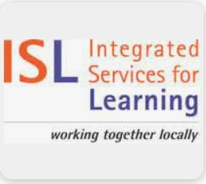 | Where difficulties persist, despite high quality interventions and appropriate adjustments, advice and support may be requested from other professionals - with the consent of parents or carers.  St Thomas More has developed effective partnerships with external support services and these play an important part in helping the school identify, assess, plan and make provision for all pupils with additional needs.  These services include:  - Woodfield School Outreach  - Educational Psychologist (Ed. Psych.)  - Speech and Language Therapy Team (SALT)  - Dacorum Educational Support Centre (DESC)  - Occupational Therapist (OT)  - SEND SAS Advisory teachers  - School Nurse  - Family Support Workers  - Attendance Improvement Office (AIO)  - Social Care  - Child and Adolescent Mental Health Services (CAMHS)  Where more than one agency is involved, a Families First Assessment (FFA) will be used to ensure that all professionals work together to realise better outcomes for the child and his / her family.

How will you help me to support my child’s learning?    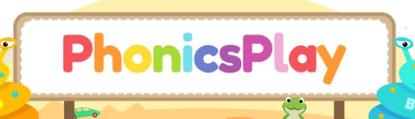 | St Thomas More believe in a fully inclusive approach to supporting pupils with additional needs and this means working in partnership with parents and carers to support in whatever way we can to enable each pupil to achieve their potential.  A curriculum meeting is held at the beginning of the academic year to inform parents of expectations and routines throughout the year.  A curriculum map for each year group is also available on the school website, along with resources to support various areas of the curriculum including Maths and Phonics.  All children receive home learning, which varies in content, length and frequency by age group. An overview of this is available on the school website.  Class teachers may signpost you to various online learning platforms which will help support your child in reaching specific targets. These include Phonics Play, TT Rock Stars and White Rose Maths.  If a specific intervention is in place, then teachers may also send home a pack of resources such as phonic sound flashcards or extra books to read. They will go through these with the parent to ensure that they feel confident in using them.  Spending time supporting your child in learning these would help your child to reach their targets. If you need further advice on supporting your child’s learning, please talk to your child’s teacher.  We regularly send emails information of specific SEND related workshops or relevant information sent to schools from the Local Specialist Provision team (DSPL8) to specific parents.

How does the school enable constructive partnership working with families?   | For children with a SEND Support Plan, termly meetings are held termly with the SENDCo to discuss a child’s progress.  Specific targets will be set or reviewed at this meeting and parental views and those of your child will feed into the plan.  We operate an “open door” policy whereby parents are welcome to meet with members of staff.  Appointments to meet with the class teacher, SENDCo or a member of the Senior Leadership Team can be arranged through the school office.  For a few children, meetings involving external professionals or review meetings will also be held regularly.  Pupils with an Education, Health and Care Plan (EHCP) will have an annual review during the school year to which input will be obtained from parents, professionals and supporting agencies.  The views of children with SEND are sought before their Annual Review meetings and included as part of their review.  There are parent representatives on the governing body who provide strategic management and act as a ‘critical friend’ supporting the work of the Senior Leadership Team and other staff when drafting and reviewing policies and parent/pupil feedback.

How will my child be included in activities outside the classroom, including school trips?  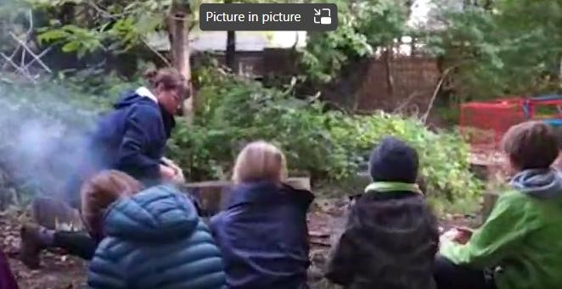 | St Thomas More operates a fully inclusive policy and children with any form of SEND are fully integrated in all aspects of school life including after-school activities whenever possible.  Pupils will be supported on a needs basis, which may be one to one support with a teacher or TA, a specific intervention programme, small group work or lunchtime support.  St Thomas More follows safeguarding and health and safety procedures ensuring that all pupils, staff and other adults are safe.  St Thomas More ensures that no pupil is excluded from educational visits or out of school activities because of their SEND or disability.  When forming a school council and seeking children’s views through pupil voice on whole school issues, we include all children across the school. This ensures that children with SEND feel a sense of belonging and they are able to have a voice in expressing what they feel would improve their education.  Relevant documents are completed detailing support and provision for specific pupils prior to visits being undertaken in line with school policy. Extra risk assessments will be carried out accordingly.  Teachers and Senior Leaders will consider the abilities of all children involved when planning school trips. Concerns from parents and children will be taken into account and, wherever possible, mitigated.  Please contact the school SENDCo if your child has any specific requirements for extra-curricular activities.
How accessible is St Thomas More?  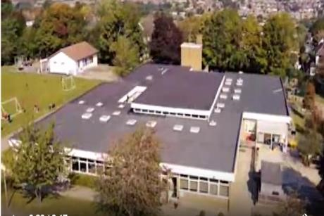 | St Thomas More follows safeguarding and health and safety procedures ensuring that all pupils, staff and other adults are safe.  Parents are encouraged to discuss individual requirements with the school by requesting a meeting with the school SENDCo.  The school will review any specific need on a case by case basis to accommodate a pupil and/or parent’s needs within reasonable adjustments.  We currently have one toilet for disabled pupils with side holders and the main school building is wheelchair accessible.  There is a disabled parking bay in the school car-park.  Our classrooms have audio-visual equipment which is visible and clearly heard by all children in each classroom.  We follow an inclusive classroom checklist which ensures that we cater for children with various specific needs.  Teaching resources and equipment are accessible to all students regardless of their needs and reasonable adjustments will be made as required from specialists eg occupational therapists.  After school and extra curricular provision is accessible to all children including those with SEND and reasonable adjustments made as required.  All students have an equal opportunity to attend trips and if needed extra help will be provided.  Further information can be found in our Accessibility Plan 2025-28 and Accessibility policy on the school website.

How will my child be supported when joining St Thomas More School or transferring to a new school?  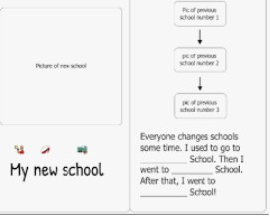 | Transition is a part of life for all children, whether it involves moving to a new class or moving to a new school. We recognise that transition is an important time for all children but especially so for a pupil with SEN and work closely with parents, children and staff to ensure these transitions run as smoothly as possible.  In Early Years school staff will organise home visits or visits to the child’s current setting, if possible, to gather more information about the child. ‘Stay and Play’ sessions allow children to become familiar with the Early Years setting in the Summer Term prior to admission. Children join the setting at an alternative time of year will also be offered ‘settling sessions’.  Planning for transitions within the wider school will take place in the Summer Term, including visits to new classrooms and sharing of social stories.  Arrangements for transition to secondary school for pupils with SEN will be planned according to individual need. Year 6 transition support begins after SATS have been completed. Transition information will be shared with the SENCO at their secondary school. This information will outline needs and support that has proven effective.  Where possible, children will visit their new school and staff from Secondary settings will visit Year 6 children at St Thomas More. Extra, tailor made transition programmes will be arranged where necessary.  Pupils are supported in their thoughts and feelings towards moving to secondary school and the aim is for them to feel fully prepared when joining their new school.  If a child moves to a new setting, a handover meeting is arranged by the SENDCo to ensure that appropriate provision can be put in place at the child’s new school. SEND Support Plans and any relevant documentation relating to the child are sent to the new setting.
How are the school’s resources allocated and matched to children’s special educational needs?  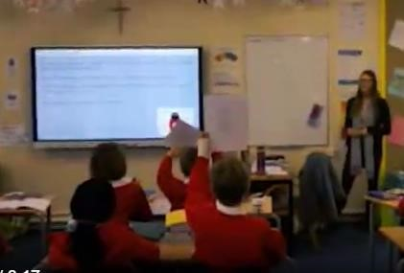 | The school’s SEND budget is primarily used to provide: additional staff support or resources that will directly benefit children with SEND.  Furthermore, it is used to facilitate:  - Whole school inclusive practice and initiatives including multi-sensory resources  - Teaching assistants to support the delivery of targeted interventions under guidance of the class teacher following assessment to identify needs.  - Provide specific resources to support differentiation including ICT  In cases where pupils have significant needs, the school may apply for High Needs Funding (HNF) from the Local Authority. This funding is allocated to a particular pupil and the school may use it in whichever way most benefits that child. Parents are involved in this process.  Funding received attached to a child with an Education Health and Care Plan (EHCP) will ensure that staffing and resources are in place to fulfil the requirement set out in the EHCP.

How are decisions made about the range of support my child will receive? | Pupil progress is reviewed by teachers and the Senior Leadership team to ensure that progress is made by all pupils, including those with SEND.  If pupils are at risk of underachievement, then interventions are put in place.  If a pupil is identified as having SEND, we will provide support that is additional to or different from the differentiated approaches and learning arrangements normally provided as part of the high quality, personalised teaching intended to overcome the barrier to their learning.  When providing support that is additional to or different from usual, we engage in a four-stage process: Assess - Plan - Do - Review ’.  For more details of our graduated and tiered approach, please refer to the “How will I know how the School Supports my Child” section above.  While the majority of children with SEND will have their needs met in this way, some may require an Education, Health and Care needs assessment to determine whether it is necessary for the Local Authority to make provision in accordance with an Education, Health and Care Plan (EHCP).

Who can I contact for further information?   | Your child’s teacher is always the first person who you should contact if you have any concerns about your child. This can be done by contacting the school office and requesting an appointment with them.  The SENDCo is Mrs Caroline Manning.  Your opinion matters to us. Each day St Thomas More Roman Catholic School makes many decisions and tries hard to do the best for all the children. Your comments are helpful for future planning. Any comments can be emailed to admin@stmore.herts.sch.uk  Please see our Complaints Policy (which is available on the school website) for information on how to provide your input.  Other organisations who can help are:  • Special Educational Needs and Disability Information Advice and Support Service (SENDIASS)  - An impartial service funded by Hertfordshire County Council. Their expertise and training in special educational needs and disabilities (SEND) and disagreement resolution help them to help parents. They offer a personalised, confidential service to help parents understand how special educational needs are assessed and managed so that they can make informed decisions about their child’s education. Tel: 01992-555847  Email: sendiass@Hertfordshire.gov.uk  Website: https://www.hertfordshire.gov.uk/microsites/local-offer/support/sendiass.aspx

Where can I find out about the local authority’s Local Offer of services and provision for children and young people with SEND?   | The Children and Families Bill requires local authorities and schools to publish and keep under review information about services they expect to be available for the children and young people with SEND aged 0 – 25. This is the Local Offer.  The intention of the Local Offer is to improve choice and transparency for families. It is also an important resource for parents and carers in understanding the range or services and provision in the local area.  To find out about the local authority’s local offer of services and provision for children and young people with SEND, visit: The Hertfordshire SEND Local Offer  Hertfordshire County Council – Information on admissions etc. https://www.hertfordshire.gov.uk/home.aspx  KIDS - A national charity providing a wide range of support services to disabled children, young people and their families. The HUBs offer information and support for parents and carers of disabled children and young people aged 0-19 in Hertfordshire https://www.kids.org.uk/hub  ADD-vance – a charity providing support to families with neuro-diverse children across Hertfordshire www.ADD-vance.org  SPACE – a Hertfordshire based charity supporting families of children and young people who are neuro-divergent SPACE Hertfordshire – Supporting families in Hertfordshire | Autism | ADHD | Neurodiversity (spaceherts.org.uk)  Hertfordshire Dyslexia Association – a registered charity supporting parents and carers of children with dyslexia living in Hertfordshire Herts Dyslexia Charity – Hertfordshire Dyslexia Association

